FOCAL LENGTH OF LENSES
PHISICS 102
Josiah Abel, Mari Martin, Dakota Johnson, Al Segovia and Erica Ruckman
April 6th, 2015
Instructor: Tamera Pavelec

OBJECTIVE: to determine the focal length of differently shaped lenses using the equation
:$\frac{1}{f}=\frac{1}{p}+\frac{1}{i}$
Where p is the distance from the object to the lens, I is the distance from the lens to the focused image either real or virtual and f is the unknown focal point.
BACKROUND: A single light source shining through a lens allows for an observer to observe the focal point of the lens in a similar fashion to a mirror. An image placed over the light source would imitate an object sitting in front of a mirror. The reflected image can either be real or virtual. With a virtual image the light rays perceived by the eyes do not pass through the image location itself. A real image light rays pass through the object from the mirror to create the object that the eye perceives. In either case all of the light rays coming from the object pass through a focal point before recreating a likeness of that object.
MATERIALS:
- Three Lenses of different construction
- Three lens holders
- A high intensity light source
- A long flat metal plate with built in meter stick, an optical rail (to mount the assemblies on)
- A sheet of white printer paper (Backdrop for image)
- ruler
PROCEDURE: Three lenses were chosen and labeled Lens A, Lens B and Lens C. The lenses were then placed into lens holders. A metal rail was placed onto a table. The light source was placed into the grove at one end of the rail so that it would not move. The lens holder containing Lens A was then placed on the rail in front of the light source. A white notebook was placed on the rail in front of the lens holder which was used as a screen to focus the images. The lights in the room were turned off and the light source was turned on. The lens holder and notebook were then moved until a clear image was cast on the notebook. The distances between the lens holder and the light source and the distance between the lens holder and the notebook were then measured. The diameter of the light source image and the diameter of the focused image were measured it was noted whether or not the image was inverted. If the image could not be focused on the notebook a small piece of paper was moved in between the lens and the light source in order to find a virtual image. Once the focused virtual image was found the diameter was measured and it was noted whether it was inverted or not. The same steps were used for lenses B and C.
SETUP: In the following images the Blue sections represent the lens used in that trial of the experiment.
Red represents where the focused image of the object was located with respect to the light source.
The yellow represents the light source shining from left to right through the blue lens.
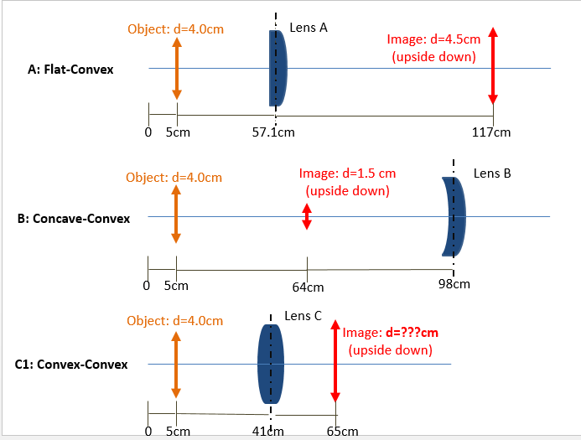
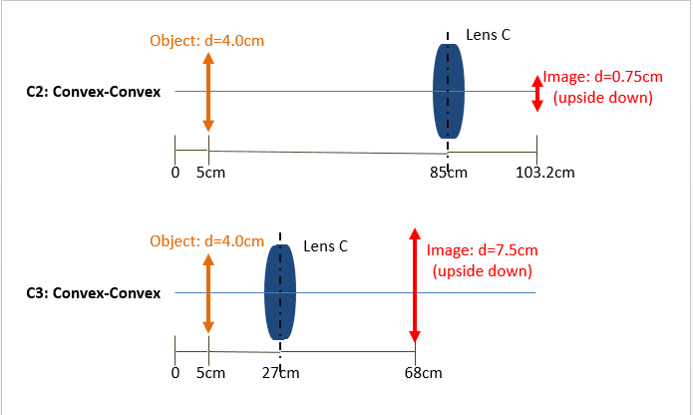
DATA: measurements taken from the experimental setups above.
(Note: the diameter of the first lens C trial image could not be determined)
Focal Length of Lenses
Position--> | Object (cm) | Object Size  (diameter -cm) | Lens (cm) |  | Image (cm) |  | Image Size  (diameter -cm) | Image
A | 5 | 4 | 57.1 |  | 117 |  | 4.5 | upside down
B | 5 | 4 | 98 |  | 64 |  | 1.5 | upside down
C1 | 5 | 4 | 41 |  | 65 |  | N/A | upside down
C2 | 5 | 4 | 85 |  | 103.2 |  | 0.75 | upside down
C3 | 5 | 4 | 27 |  | 68 |  | 7.5 | upside down

LENS | A | B | C1 | C2 | C3 | Units
Distance from Source to Lens (P) | 52.1 | 93 | 39 | 80 | 22 | cm
Distance from image to Lens (i) | 59.9 | 34 | 21 | 18.2 | 41 | cm
Focal Point (F) | 27.86419643 | 24.8976378 | 13.65 | 14.82688 | 14.31746 | cm

RESULTS:
The focal point for Lens A was 27.86 cm away from the lens. Real Image.
The focal point for Lens B was 24.90 cm away from the lens. Virtual Image.
The first focal point for Lens C was 13.65 cm away from the lens. Real Image.
The second focal point for Lens C was calculated at 14.83 cm away from the lens. Real Image.
The Third focal point calculated for Lens C was 14.32 cm away from the lens. Real Image.
The average focal point for C was 14.26 cm from the lens.

CONCLUSION: The focal point for each of the lenses could be determined after shining the high intensity light through lens, then adjusting the backdrop until the clearest image could be observed. By using the equation given and the measurements taken in the experiment, the focal point of the lens was determined.

